Light Source

GameMaster follows int TimeBracket.

TimeBracket ++ whenever:

• Player enters a red room  
• Player rests to recover health  
• Player dies

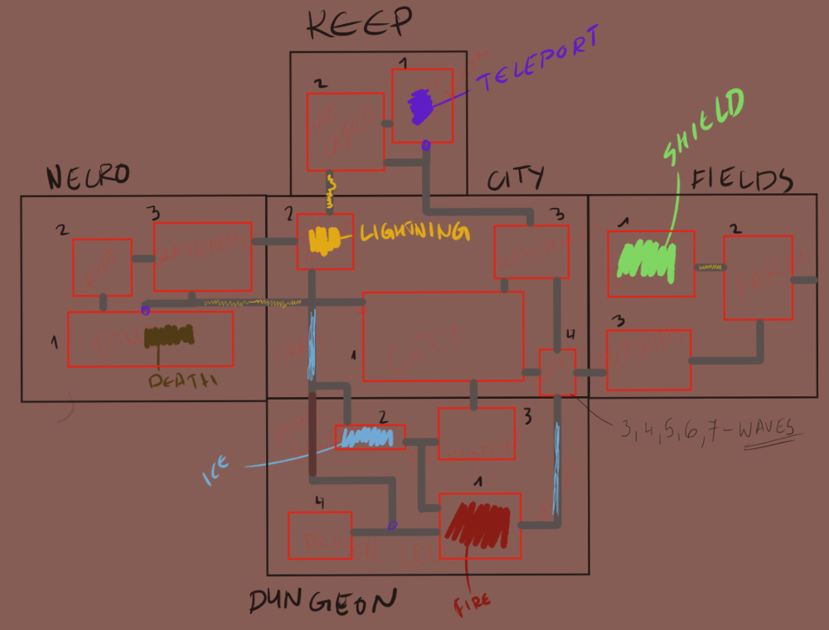

The game ends:

• At the end of TimeBracket20  
• When the player exits Farm/Fields to east  
• Player defeats Boss

Boss Route

|  |  |  |  |  |  |  |  |
| --- | --- | --- | --- | --- | --- | --- | --- |
| TB | Location |  | TB | Location |  | TB | Location |
| 1,2,3 | N1 |  | 10,11,12 | K1 |  | 18 | F2 |
| 4 | N2 |  | 13,14 | C3 |  | 19 | F1 |
| 5 | N3 |  | 15 | C1 |  | 20 | F2 |
| 6,7 | C2 |  | 16 | C4 |  |  |  |
| 8,9 | K2 |  | 17 | F3 |  |  |  |

# Story

## NPCs

DUNGEON – Otto, Criminal (link to C1),

CITY – Captain, Gang Leader, Villager-turnt-Soldier (from F3)

FIELDS – Villager-to-turn-Soldier, The Farmer & His Wife, The Blacksmith

KEEP – Mage/Archivist, Queen

NECRO – Boss

Player

**Resources**

Health bar (first 30% of the health bar represent 50% of max health)  
Stamina – recovery rate varies based on player state

Unceremonious Death preventer (no death from traps, on CD)

**Controls**

Jump(A), Attack(X), Interact/Pick-Up(Y), Block/Parry(B)  
SwapAbility/OpenToolWheel(RT), Lantern(RB)   
Dash(LB), Throw Weapon (LT)  
Recharge (RT + LT)  
Move – LStick  
Aim – RStick

**Abilities**

Fire, Cold, Lightning, Shield, Teleport

**States**

• isGrounded – touching ground  
• isStill – velocity = 0  
• isAirborne - !isGrounded && !isFloating  
• isHurt – just took damage  
• isArmed – holds weapon  
• isBlocking – holding Block button  
• isFloating – uses float  
• isDashing – is in dash  
• inDialogue – yarn active  
• isBurning – on fire  
• isFrosted – slowed down  
• isZapped – can’t jump (can’t attack for enemies)  
• isWanted – has killed people

Checkpoint system

Saving game

public StaminaDrain(); float staminaCost

3 levels of Stamina – 100%, 99%-51%, 50% or lower

Health bar – 2 states

WeaponScript – Hit(); damage; force; hitflash on collision; durability

InteractionScript – importantConvo bool to put player inDialogue

Game architecture first draft

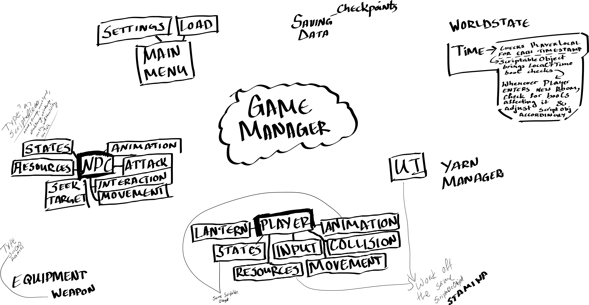

World structure draft 2

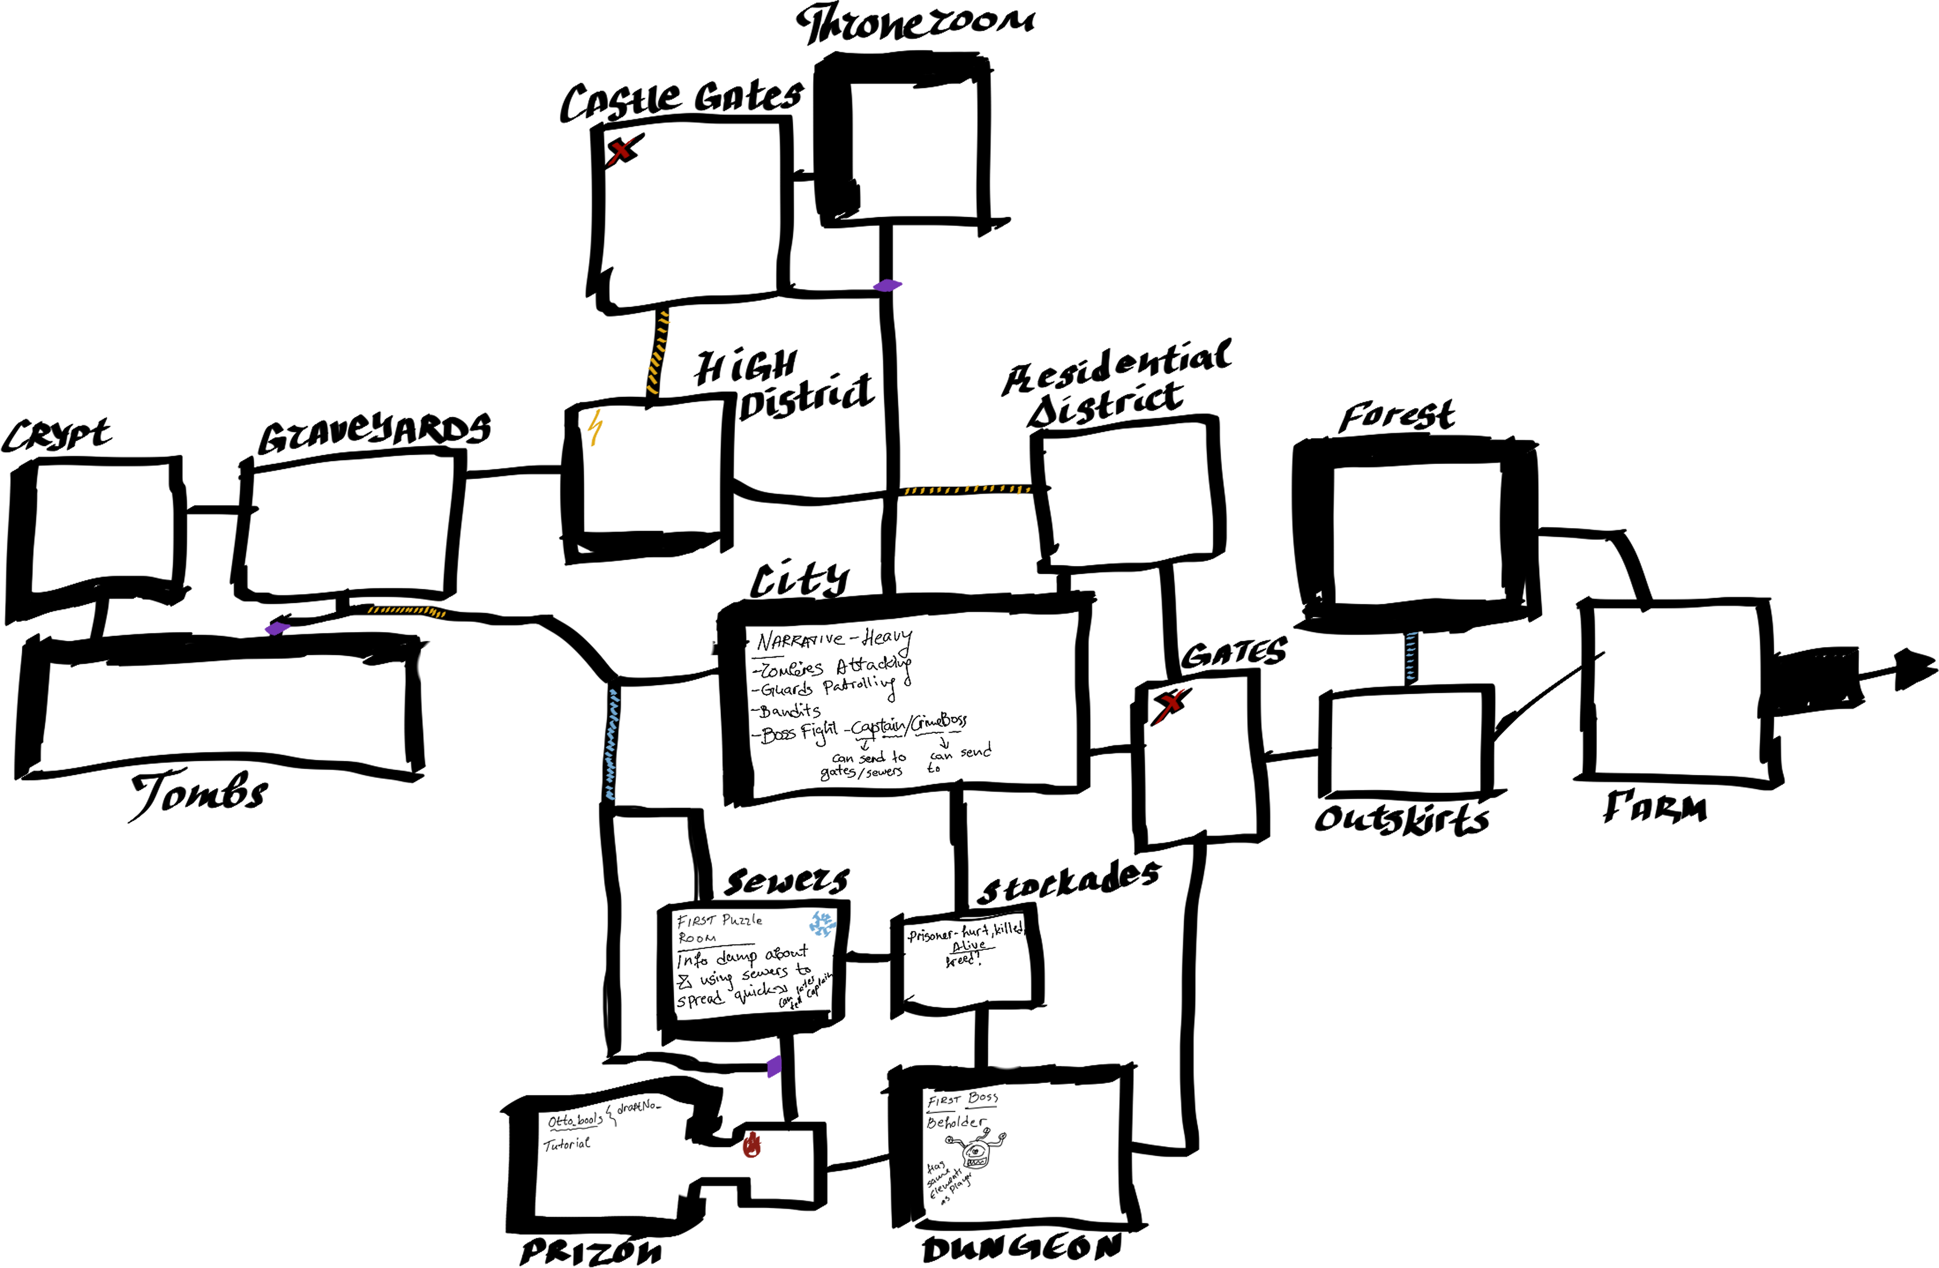

# **Live Training 8th August 2016 - Ability System with Scriptable Objects**

<https://www.youtube.com/watch?v=bvRKfLPqQ0Q>

# **What are ScriptableObjects?**

<https://unity.com/how-to/architect-game-code-scriptable-objects>

# **Breaking up Code in Unity**

<https://www.youtube.com/watch?v=_vj1GASSO9U>

# **Easy Simple Game Architecture in Unity Using Events**

<https://www.youtube.com/watch?v=Ve-8kGnj8u4&t=274s>

# **Jump Attacking Enemy AI in Unity 2D**

<https://www.youtube.com/watch?v=tNddFEcE0Ss>

# **Unity Animator**

<https://www.youtube.com/watch?v=fviU0V6nivs>

# **Enemy AI Enemy that moves and shoots at the player**

<https://www.youtube.com/watch?v=lHLZxd0O6XY>

# **Boss Enemy AI Unity**

<https://www.youtube.com/watch?v=_vh9mCskp_o&t=267s>

# **How To Make Game Object Or Character Move Along Bezier Curve With Simple C# Script**

<https://www.youtube.com/watch?v=11ofnLOE8pw>

# **Predicted Trajectory path of Projectiles**

<https://www.youtube.com/watch?v=3DUmpVi82q8>

# **Escaping Unity Animator HELL**

<https://www.youtube.com/watch?v=nBkiSJ5z-hE>

Game Architecture

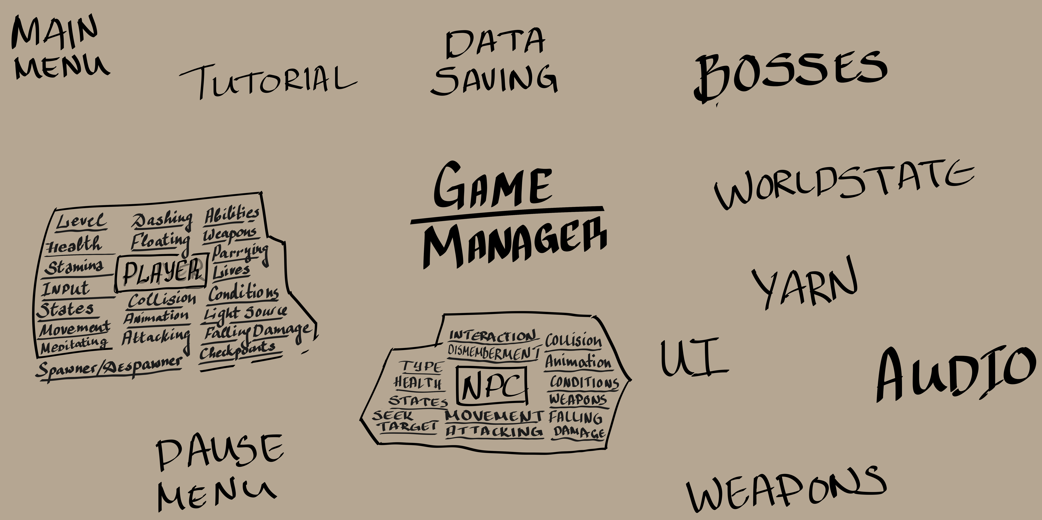

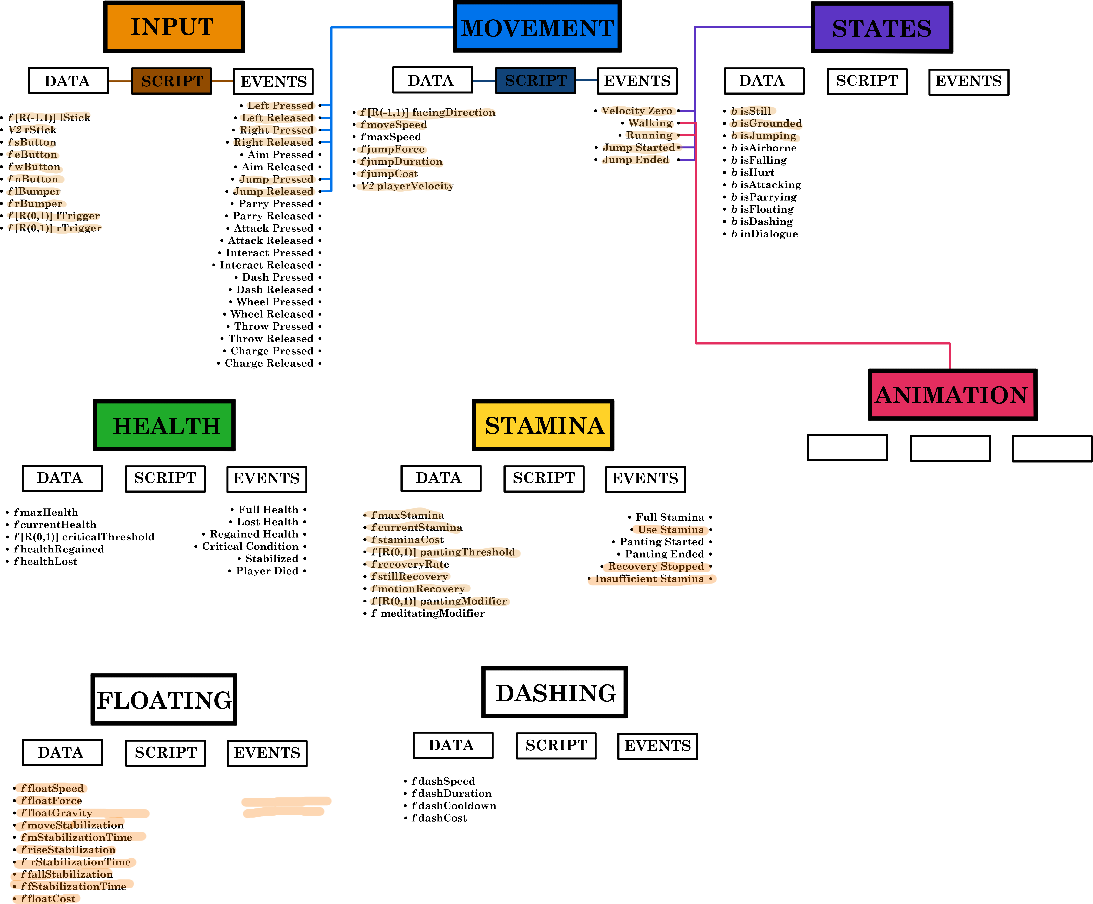

<https://app.flourish.studio/visualisation/5047926/edit>

Data – Size 1

Script – Size 10

Event – Size 4

---

Passes information to – Width 1

Raises – Width 12

Responds to – Width 5

yDistance < 0 && yDistance > -10

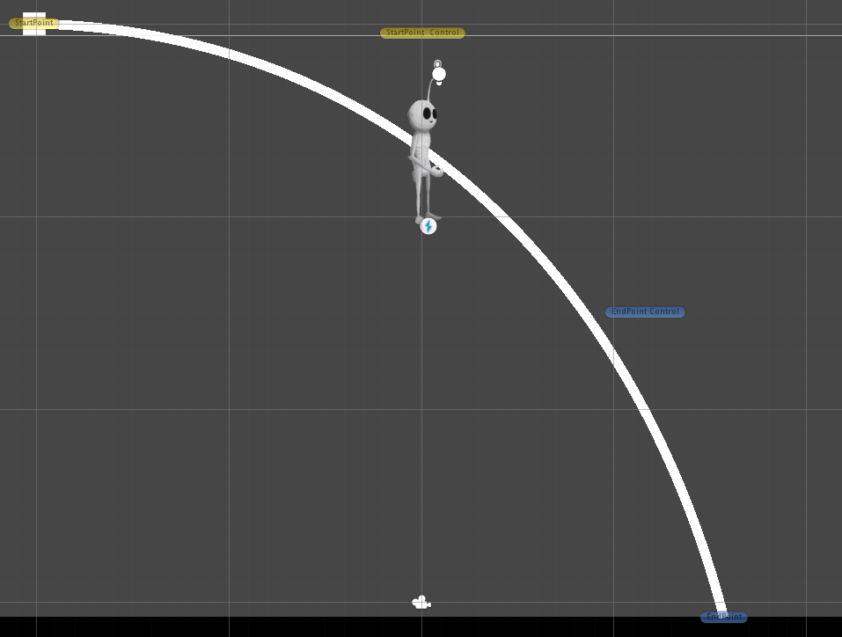

yDistance < -10

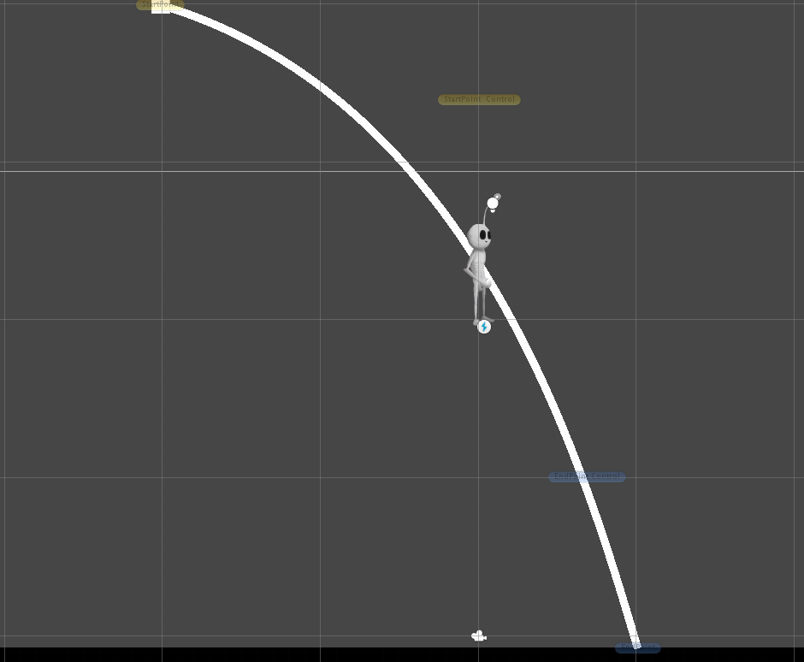

yDistance < -25

